In this topic we are going to learn the methods of manipulating HTML and CSS elements using the DOM.

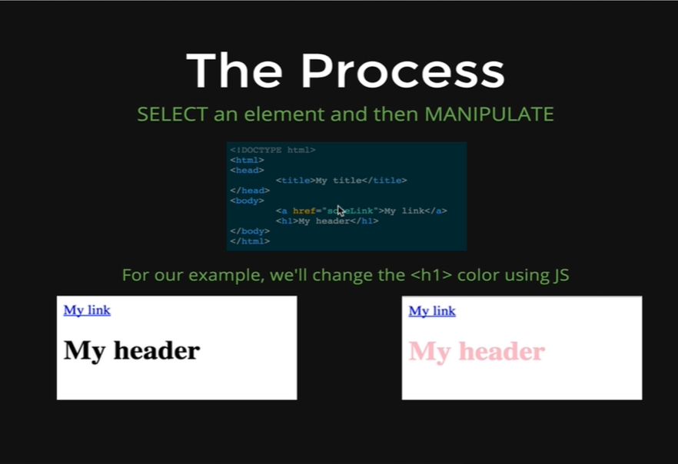

We have boiled down the whole process in to two keywords SELECT and MANIPULATE. Just like CSS where we write a Selector to select something with a class of special or all *h1*s or all *img* tags, we select elements and then we apply styles, like background color Purple, or border 1px solid black. With JavaScript and DOM manipulation, we also select elements, although we do it in a very different way, we write JavaScript code that goes and select elements and returns them back to us and then we change properties on them. So, we select something and then we manipulate it.

In next few pictures we are going to show how we can select the *h1* text of *My header* and how we can change the font color to be pink. We will not focus much on the syntax in this lesson, but more on the concepts.

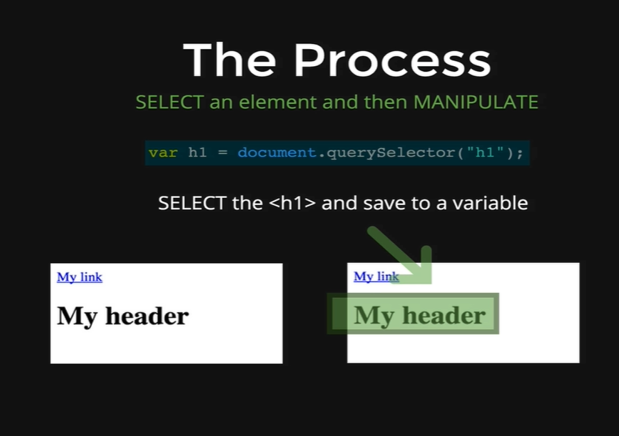

In this picture we are going to see how we can select the *h1*. Just like CSS there are a lot of different ways of selecting an element. In picture the line of code *document.querySelector(“h1”)* is going to select the *h1* content *My header* on the page, which we have highlighted with a green box, so we can see what is being selected. We are initializing the query selector method to the variable *h1.* This query selector method returns an object that represents the *h1* with the *My header* content and it stores that object in the *h1* variable. This is the selecting process. The next part is manipulating it.

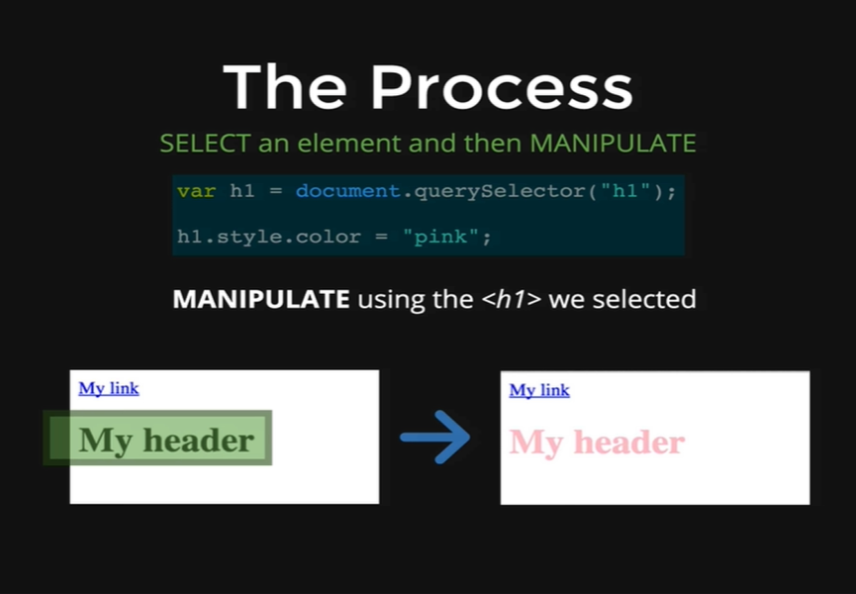

To manipulate the object inside the variable we can do all sorts of things. All that we are going to do here is change the color of the *My Header* font to be pink. We just write *h1,* which is our variable that has the object representing the *h1*, and then we put a dot and after that and write *style,* which is one of the properties and that style property is a huge object with a bunch of other properties and *color* is one of those properties.

*h1.style.color = “pink”*

That’s we all need to do, and the browser sees that we changed that property to pink and it automatically updates the object inside the variable by turning it pink.

So, first we selected it,

*var h1 = document.querySelector(“h1”);*

And then we manipulate it,

*h1.style.color = “pink”;*

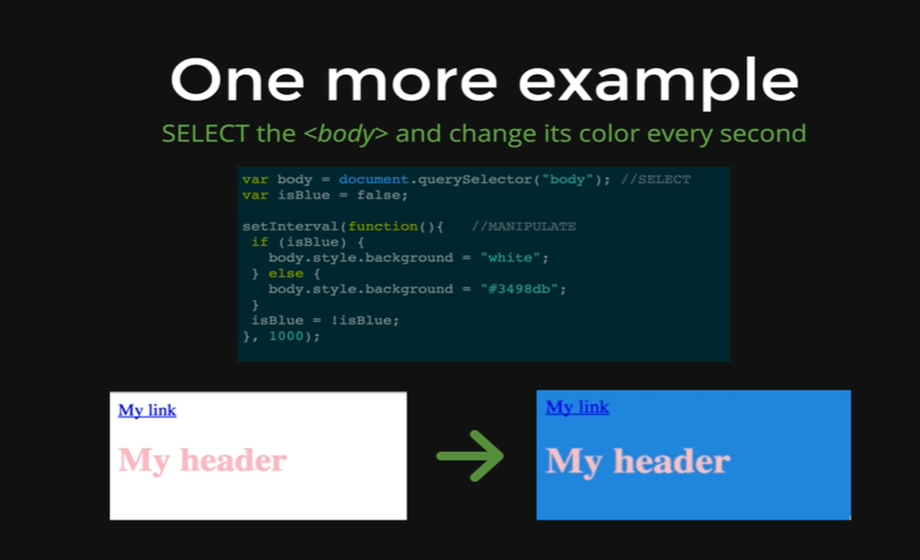

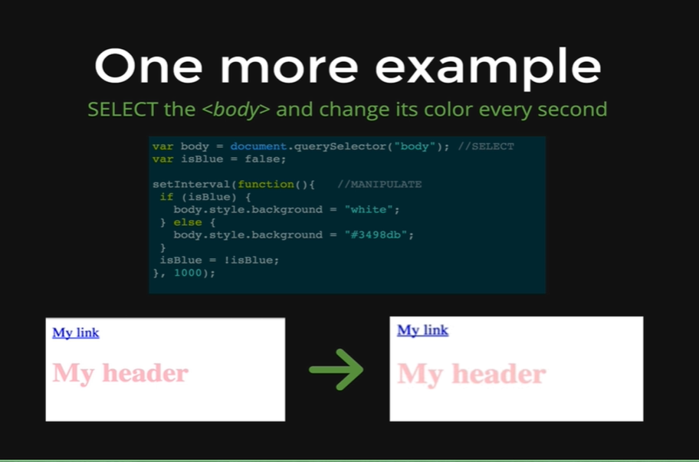

We have one more example which is a little bit more complicated. We are doing a very simple animation where every second we are changing the background color of the body between blue and white. So, first we need to select the body and then manipulate it.

*var body = document.querySelector(“body”); //SELECT*

We are selecting the body by passing the body tag as an argument to the *document.querySelector* method and initializing it to the *body* variable. This method will return an object representing the content inside the body and that will be stored in the variable.

*var isBlue = false;*

Then we have a variable *isBlue* which is just a Boolean that we are going to use, because we need to know if we are going from blue to white, or from white to blue. It starts as false and then we are using the *setInterval* function,

*setInterval(function() {*  *//MANIPULATE*

*if (isBlue) {*

*body.style.background = “white”;*

*} else {*

*body.style.background = “#3498db”*

*}*

*isBlue = !isBlue;*

*}, 1000);*

The *setInterval* function basically takes two arguments, the first one is some code to run, a function, and the second one is a number or a time in milliseconds, in this case this is 1000 milliseconds or 1 second, and at every 1 second, it will call the function that’s got taken as the other argument. This function just checks if the background of the site is currently blue or not, if it is blue then we change it to be white, if the background is white then we change the background to be blue.

Take a closer look inside the function code we have *if(isBlue)* which is just a variable inside the *if* parentheses, and it starts as false as we have set it while initializing it at the beginning of our code, which is why the if statement does not run but the else statement does which sets the *body.style.background* to be equal to *#3498db,* which is the hexadecimal format of blue, thus the background changes to be blue. Then we change the *isBlue* variable from false to true through the code,

*isBlue = !isBlue;*

Then, after 1 second the function runs again, this time the *isBlue* variable is already true, so when the function is called, the condition inside the *if* statement parentheses is true which is why the if statement runs, thus setting the background white through the code,

*body.style.background = “white”;*

The background changes to white, the else statement does not run and then we change the *isBlue* variable back to false and then this moving back and forth keeps on going forever. This shows we can do things more complex than just changing an *h1* from black to pink.

To wrap everything up there is only two words Select and Manipulate. We Select, we grab some objects that represent elements and then we Manipulate them by doing something to them.